Shashank K

SE21UCSE198

CSE 3

DAA Assignment -2

**Goal :** Comparing the time taken by a recursive function and a non-recursive function for finding the value of function 2^n.

**Non recursive method**

**Function :**

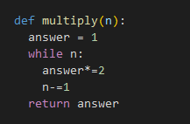

The time taken for various values of n is as follows.

|  |  |
| --- | --- |
| **Value of n** | **Time taken in seconds** |
| 1 | 2.15e-06 |
| 10 | 2.62e-06 |
| 100 | 1.71e-05 |
| 500 | 8.08e-05 |
| 955 | 1.82e-04 |

**Recursive Method**

**Function :**

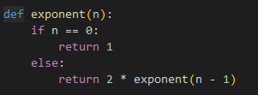

The time taken for various values of n is as follows.

|  |  |
| --- | --- |
| **Value of n** | **Time taken in seconds** |
| 1 | 3.57e-06 |
| 10 | 1.21e-05 |
| 100 | 4.67e-05 |
| 500 | 2.61e-04 |
| 955 | 5.41e-04 |

**Observations:**

* I was not able to test for higher values of n because of the recursion limitation in python. But it would’ve been completely possible with looping method.
* Just from the table we can clearly see that in every case, looping method has proven to be faster than recursive method and at higher value of n it has proven to be even better.

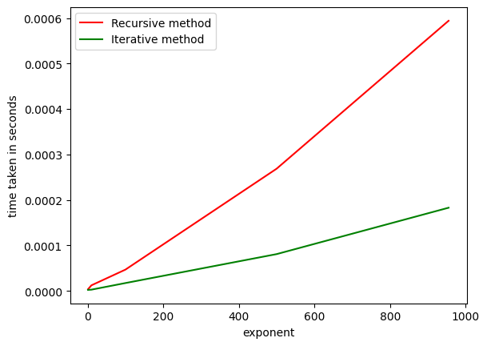

* The reason for this might be the depth of recursion, repeated number of function calls. Each function occupies a lot of memory hence the poor performance.

**Calculating Complexity :**

